The Islamia University of Bahawalpur
Department of Information Technology
Faculty of Computing


SOFTWARE DESIGN DOCUMENT (SDD)
for
Online Appoinment Booking System
Version 1.0

By
Student Name: Fatima Javed
Roll No: S25BINFT7M04027
Session: Spring 2025 – 2027
Supervisor: Dr Mustafa Hameed
Bachelor of Science in Information Technology

Revision History

Date | Description | Author | Comments

Document Approval
The following Software Design Document (SDD) has been accepted and approved by the following:
Signature |  | Printed Name | Title | Date
 | .

Supervised by
Dr Mustafa Hameed
Signature

INTRODUCTION

Advent

the subsequent subsections of the software program requirements specifications (SDD) record ought to provide a outline of the entire SDD..

1.2 Motive
The Online Appointment Booking System is designed to take the inefficiencies out of manual paper based booking systems and to help manage services more efficiently. Currently long waiting times, errors and poor customer record handling are all issues that can be caused by manual appointment booking systems. This online system for appointment booking provides a fast, efficient and convenient way for customers to make appointments, and for staff to mange those appointments. It helps to maximise use of time, save staff time and reduce workload, as well as improving customer satisfaction.

1.3) Target audience
The target audience for the Online Appointment Booking System are the potential users of the system that include the businesses, service providers and customers. This system will be particularly relevant to clinics, salons, consultants, educational institutions and corporate offices. It will benefit the customers who are looking for a convenient and time saving solution. Administrators and staff members involved in booking the appointments will also be able to use this system to manage their schedules efficiently. The users of this system will have basic knowledge of computers and internet.

1.4) Scope
Online Appointment Booking System - automates schedule management, tracking of scheduled and ongoing appointments. Online users can schedule an appointment, change or cancel it. Administrators can monitor, organize and manage all upcoming appointments. The system can be extended with SMS notifications, online payment processing, generation of reports, statistics and more. It can be customized to meet the needs of any industry, and used through computer, laptops, tablets, smartphones and more. By automating routine tasks, the system will help reduce labor costs and make the appointment booking process easier for both clients and staff.

1.5) Definitions, Acronyms and Abbreviation
Term / Acronym | Full Form / Definition
SRS | Software Requirements Specification; a document that describes the functionality, features, and constraints of the Online Appointment Booking System.
Online Appointment Booking System | A web-based application that allows users to schedule, manage, and track appointments with service providers online.
PHP | Hypertext Preprocessor; a server-side scripting language used to develop the Online Appointment Booking System.
Web Application | A software application that runs on a web server and is accessed through a web browser for booking and managing appointments.
Appointment Scheduling | The process of selecting and reserving a specific date and time slot for a service through the system.
User Management | The process of creating, updating, and maintaining user accounts, including customers and administrators.
Booking Management | The functionality that allows users to create, update, cancel, and view their appointments.
Notification System | A feature that sends alerts or reminders to users regarding their appointments via email or SMS.
Customer | A user who accesses the system to book, view, or manage their appointments.
Admin | An authorized user responsible for managing appointments, users, schedules, and system settings.
Time Slot | A specific period available for booking an appointment.
Dashboard | A web interface that displays summarized information such as bookings, schedules, and system status.
Database | A structured collection of data used to store user information, appointment details, and system records.
Authentication | The process of verifying the identity of users before granting access to the system.
Authorization | The process of granting users permission to access specific features based on their roles.
Performance | The ability of the system to handle multiple bookings efficiently and respond within acceptable time limits.
Security | Measures implemented to protect user data and prevent unauthorized access to the system.

2.SYSTEM ARCHITECTURE

2.1 Architectural Design

2.1.1 User Interface (UI) and User Experience (UX)
The system is also very easy to use, for booking appointments in an easy way. The system has a very clear design, with easy navigation and using fonts of appropriate size, in a responsive web design. The system is also very easy to fill up forms to view available time slots and to book services and appointments. Simple UX helps to keep things smooth and prevent users wasting time on figuring out how to use the system.

2.1.2 Backend Architecture
The backend is built on PHP and a database management system. This is where all the calculations and information storage happens. It takes care of handling user requests, scheduling appointments and dealing with the rest of the logic of the system while the front end handles the user interface. The system is designed to handle multiple users accessing it at the same time while maintaining high levels of scalability, reliability and responsiveness.

2.1.3 Security
User authentication and authorisation features help limit access and enable secure login, data encryption, transmission and storage. All user information such as email addresses, username, password and other details are secured, encrypted and protected from access by any unauthorised third party.

2.1.4 Search and Filtering
Our system comes with a fully integrated search feature that allows customers to find the exact service and availability they require within seconds. We also include an innovative filtering system that enables customers to book appointments based on date, time and type of service. Filtering by these criteria makes it easier for customers to browse through our available services and find the perfect slot to book the exact service they require on the desired date and time.

2.1.5 Overall Performance
We've gone to great lengths to ensure our system performs flawlessly under varying loads, and gives users a smooth and fast experience. It's optimised to cater for multiple users, at the same time, posting bookings, whether it's a small handful of rentals a week or hundreds a day. The system has been engineered to respond rapidly, performing database queries and processing user input using advanced coding techniques to maximise uptime and reduce administrative work.
2.2) Decomposition Description

User Registration and Login Module
User Account Module allows users to register an account and login to the system. The module also authenticates login details and allows users to recover lost password and manage their accounts, making the system accessible, secure and easy to use for end users and administrators alike.

Appointment Booking Module
This module makes it very easy for your customers to book an appointment with you. They simply select the date and then choose the time slots within that date that are available to them. The module displays real time availability and will also prevent any double bookings. As soon as the appointment has been scheduled the customer can confirm it instantly. Easy to use, reducing administration for your customers and staff.

Appointment Management Module
The module to manage existing appointments allows customers and administrators to view, edit and cancel existing appointments. This feature helps to organize appointments and to monitor all appointments that are scheduled so far. It prevents confusions when managing service appointments within the module.

Admin Management Module
The Admins module gives the administrators of a system full control. With Admins users can manage users, change schedules and appointments, and configure system settings and services.

Notification Module
This module sends reminders and notifications to users of upcoming and scheduled appointments. It allows for contacts to be notified by email or SMS of booking confirmations, updates and cancellations. Helps to prevent no shows and keep users informed, it is especially useful in providing a 2 way connection between your customers and service providers.

Database Management Module
Store module is responsible for storing and retrieving user information, and associated appointments etc. It endeavours to keep the information current, consistent and up to date, whilst providing fast and efficient data processing.

2.3) Format cause

2.3 User Interface and User Experience Requirements

2.3.1 Visual Design
Clearly labelling of icons and buttons should be a key feature so that the user knows what each icon or button represents immediately. The design and overall look and feel of the system should enable the user to book an appointment, and be able to use the system effectively.

2.3.2 User Experience (UX)
Book Online System automatically guides users to a seamless booking experience. The system is simple for users to follow enabling a booking appointment in the shortest amount of time possible and allowing them to instantly book services, timeslots etc. Within the Book Online System for website, users are guided through the process effortlessly with minimal steps to the booking confirmation, reducing user error and increasing user satisfaction.

2.3.3 Responsive Interface
The developed system includes an open website that is optimized for use with different devices such as mobile phones, tablets as well as standard computers. The layout and content automatically adjusts depending on the screen size of the device. Therefore, analyses can be performed at any time and location.

2.3.4 Security
Security is implemented on the website to protect both user information and system information. The website uses a secure login system with full support for authentication and authorisation, as well as data validation and encryption to help prevent unauthorised access to user information and appointment details.

2.3.5 Performance
We have tried to optimize the system as much as possible to ensure that it runs very fast. The system has been designed to handle with multiple users logged in at the same time, as well as handling numerous bookings at any time. The code has been written in a proper manner, and the database has been optimised to ensure that there is little to no delay. This in turn ensures that there is little to no room for error, and the system is always online, always ready to serve your customers, as well as your administrators.

2.3.6 Search and Filtering
The search and filtering facility is a new feature which allows our clients to find available appointments more quickly and easily. Search results can be filtered by date, time or by specific treatment, allowing clients to browse for appointments which suit them best. Once results have been filtered, clients can also browse manually to find an appointment time which best suits their needs. This feature will save clients hours of searching manually for an appointment and ensure that clients find the relevant appointments to increase client satisfaction.

2.3.7 Integration with Third-Party Tools
The system can be integrated with third party applications, such as e-mail services, SMS gateways and online payment systems. The system can also be integrated with other calendar applications on PCs and mobile devices. This feature can enhance functionality of the system by sending reminders and notifications to the clients and patients, and also by enabling online payments, making appointments booking easier and more convenient.

Class diagram
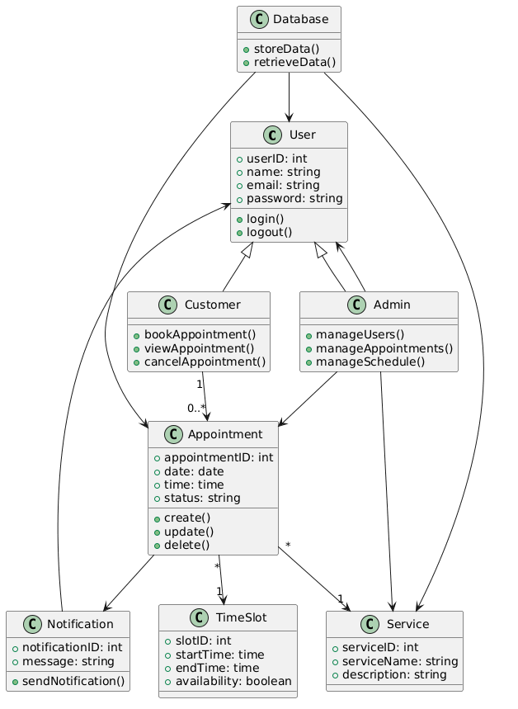
Activity diagram
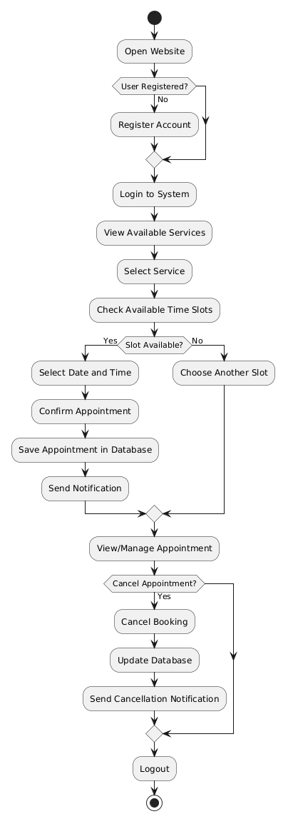
Data flow diagram (0 level)
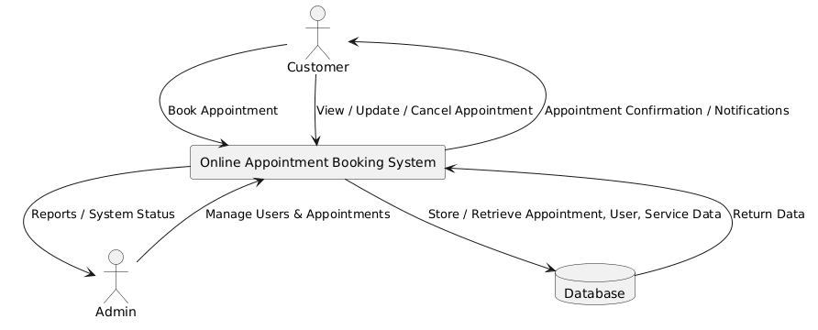
ER-diagram
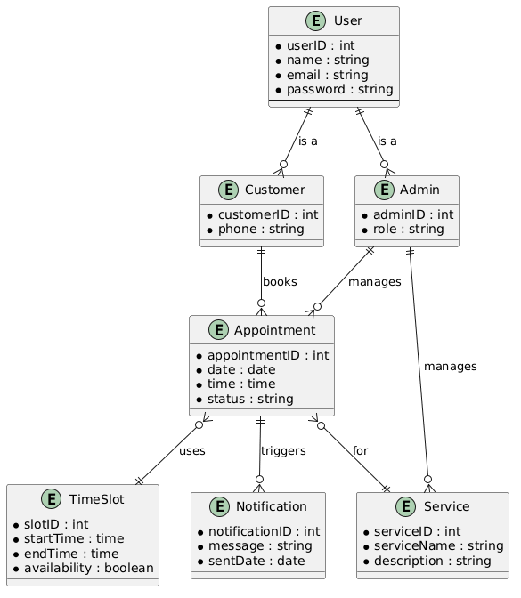

3.DATA DESIGN

3.2)Data Dictionary
Data Element | Type | Format / Size | Description
user_id | Integer | 4 bytes | Unique identifier for each user in the system.
name | String | 100 chars | Name of the user (customer or admin).
email | String | 100 chars | Email address of the user for login and notifications.
password | String | 100 chars | User account password, securely stored.
role | String | 50 chars | Role of the user (Customer/Admin).
appointment_id | Integer | 4 bytes | Unique identifier for each appointment.
service_id | Integer | 4 bytes | Identifier for the service selected in the appointment.
service_name | String | 100 chars | Name of the service offered.
date | DateTime | ISO 8601 | Date of the scheduled appointment.
time | DateTime | ISO 8601 | Time of the scheduled appointment.
slot_id | Integer | 4 bytes | Identifier for the time slot selected.
availability | Boolean | 1 byte | Indicates if a time slot is available (true/false).
notification_id | Integer | 4 bytes | Unique identifier for notifications sent to users.
message | String / JSON | Variable | Content of the notification (email/SMS/dashboard).
timestamp | DateTime | ISO 8601 | Time at which the notification or system event occurred.
report_id | Integer | 4 bytes | Unique identifier for system reports.
report_type | String | 50 chars | Type of report generated (daily summary, usage trend).
report_content | JSON / String | Variable | Detailed content of the report including metrics and analytics.
alert_id | Integer | 4 bytes | Unique identifier for system alerts.

4.HUMAN INTERFACE DESIGN

4.1 Overview of User Interface
The Human Interface of the Online Appointment Booking System offers user friendly interaction with the system. Everything is designed to be easy to use with clear navigation menus, clickable buttons, forms and interactive dashboards to book, manage and view appointments. The design is simple, accessible and efficient to use. and offer the best user experience.

Screen Images
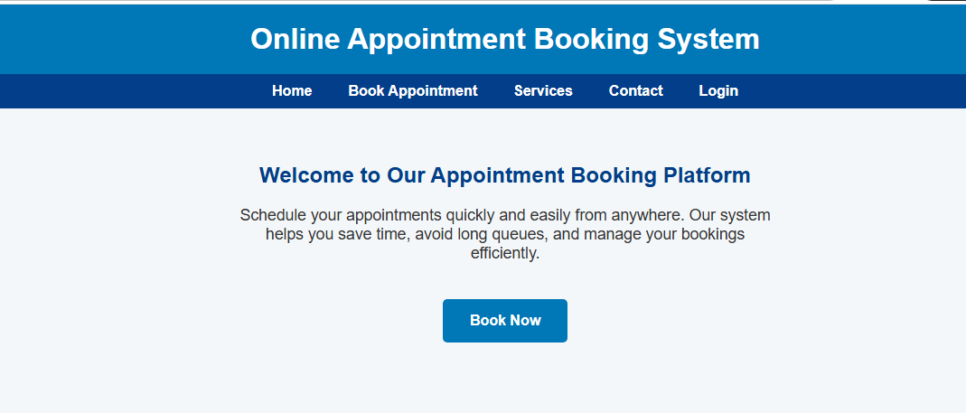

The design will be contemporary to this website

5. REQUIREMENTS MATRIX
Req. ID | Requirement Description | Type | Priority | Module/Feature | Verification Method
FR-1 | System shall allow users to register, login, and manage their accounts. | Functional | High | User Management | Test user registration, login/logout, profile updates
FR-2 | System shall allow customers to book, update, and cancel appointments. | Functional | High | Appointment Booking | Test creating, updating, and cancelling appointments
FR-3 | System shall display real-time availability of services and time slots. | Functional | High | Appointment Booking | Compare displayed availability with database records
FR-4 | System shall allow administrators to manage services, schedules, and users. | Functional | High | Admin Management | Verify admin can add, edit, or remove users/services
FR-5 | System shall store user, appointment, and service data in a database. | Functional | High | Data Management | Verify data stored correctly and is retrievable
FR-6 | System shall allow search and filtering of appointments by date, service, or user. | Functional | Medium | Search & Filtering | Test filtering by date, service type, or customer
FR-7 | System shall send notifications/reminders to users for upcoming appointments. | Functional | High | Notification / Alerts | Simulate upcoming appointments and check notifications (email/SMS)
FR-8 | System shall allow configuration of service availability and time slots by admin. | Functional | High | Admin Management | Test creating, updating, and deleting time slots and services
NFR-1 | System shall provide a responsive UI suitable for desktops, tablets, and mobile devices. | Non-Functional | High | User Interface | Test on different screen sizes and devices
NFR-2 | System shall load dashboards and appointment data with minimal latency (<2 seconds). | Non-Functional | High | Performance | Measure response times when viewing bookings or schedules
NFR-3 | System shall ensure secure user authentication and encrypted storage of sensitive data. | Non-Functional | High | Security | Verify login security, password encryption, and data protection
NFR-4 | System shall be scalable to support multiple simultaneous bookings and users. | Non-Functional | Medium | Backend / Appointment Management | Test multiple bookings and users under load
NFR-5 | System shall maintain logs of all user actions, appointment changes, and system events for auditing. | Non-Functional | Medium | Data Management / Logging | Review log files for completeness, accuracy, and integrity
NFR-6 | System shall integrate securely with external notification services when required. | Non-Functional | Low | Integration | Test secure data exchange with email/SMS services

